Face detection is a computer vision task that identifies the places of a faces in a digital image

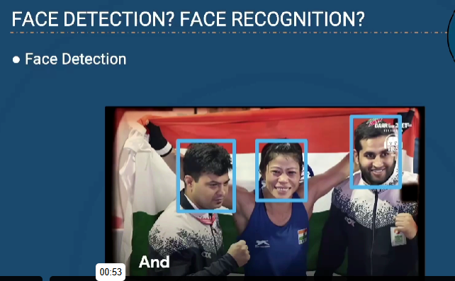

But in face recognition we have not find only the places of face we identify who’s face is this, by comparing the training faces with real faces



Above is the training faces with that faces machine will going to recognize on below faces, is one of train person’s face is there are not.

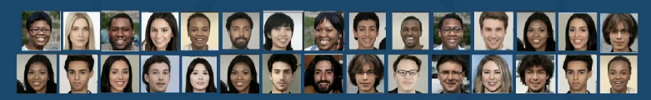

**HOW DETECTION WORKS?**

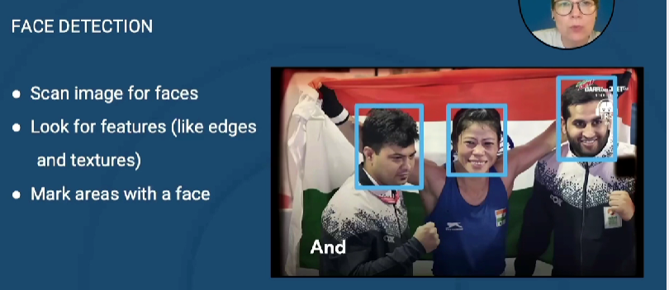

In face recognition we have to store each and every face’s shape like what is length between month and eye, what is the length between nose and month, like all these length will gives you the shape of the face, so that shape of the face will be stores as a vector here, and that is also called as faceprint

Face embedding is a technique used in **facial recognition** and **face verification** to represent a face as a numerical vector in a high-dimensional space. This vector captures unique facial features, allowing comparison and classification of faces.

In the below image the graph is the vector that store all the shape of the face, is any of the shape of the face in real world data matches with the existing vector then we can simple recognize the face

Assume red graph dot is the vector that model trained with, and blue is the face that feed as input to model to make recognition, if any of the existing vector having the current face vector(input) then a match will be happed, this is how face recognition works.

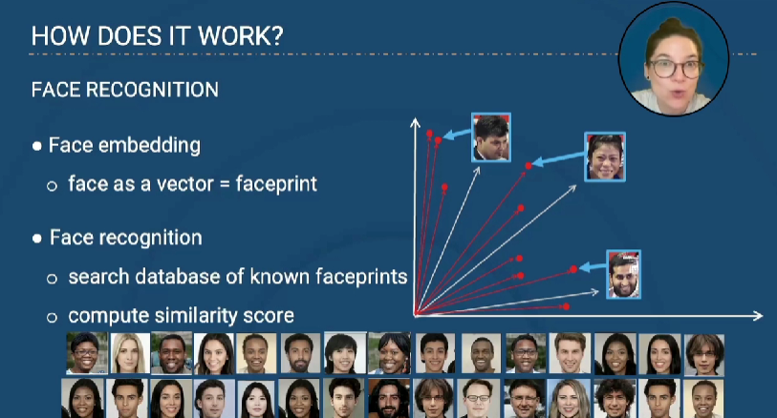

To do face recognition two methods are used that is in below image.

